University of Southern Indiana
Pott College of Science, Engineering, and Education
Engineering Department
8600 University Boulevard
Evansville, Indiana 47712
Slope Stability Flume
Calvin Brinton and Ethan Hahn
TECH 471 - Senior Project
Fall 2021
Approved by:
Faculty Advisor: David Ellert, P.E. Date
Approved by:
Department Chair: Paul Kuban, Ph.D. Date
Contents
Abstract 3
Introduction 3
Objective 3
Deliverables 3
Background 3
Statement of the Problem 3
Similar Projects 4
Teamwork 5
Discussion 5
Design 1 6
Design 2 6
Design Process 7
SOLIDWORKS 7
Construction 8
Future Use 9
Bill of Materials 10
Choice of Materials 10
Cost Analysis 10
Conclusion 10
Personal Findings 10
Results 10
Appendix 11

Abstract
This scope of this project is to design and construct a testing flume to be used by the USI civil engineering department. The flume will contain moist sand while all walls and base of the flume will be constructed of a Lexan material with a steel support structure. A floor jack will be provided that can raise the flume to manipulate the angle of the slope. The moist sand material, steel support structure, and Lexan sheet weights were all calculated to verify what caster wheels were appropriate for this flume.

Introduction

Objective
The aim of this project is to:
Design and build a slope stability flume that can measure controlled and variables.
The motivation for this project comes from the USI (University of Southern Indiana) Civil Engineering Department and their need for a slope stability testing flume. This type of flume can be constructed on a lesser scale while also still being able to supply realistic testing results similar to real world scenarios. The goal of this team is to raise awareness of slope stability by providing this testing flume so it can be used to gather useful data and information.

Deliverables
The deliverables needed for this project consist of the following:
- A functional Slope Stability Flume
The end result of this project is composed of a constructed flume for later demonstrations. This flume also has the ability to be used for other general uses such as a material storage bin and mobile student table for the USI Engineering Department.

Background

Statement of the Problem
Slope stability testing is used in today’s world to measure several types of environmental situations such as landslides, volcanic climates, or even on construction sites. When testing in these scenarios, a sophisticated version of testing includes the use of sensors, the ability to add water attributes, and intricate flumes on a much larger scale. Slope Stability is an important and reoccurring concept. It is taken into consideration with all types of building sites such as bridges, dams, houses/buildings, and all general structures that may be on any angled slope or terrain. Anytime these structures are built on slopes, there is always vigorous testing and data acquisition to ensure that the structure is being built safely and effectively on the given terrain. This team's project is directly related to slope stability and the testing that is associated with it. While the team’s primary goal of this project is only to construct a testing apparatus, a general understanding of slope stability through experimentation while also being the importance and relation that slope stability has with the world.

Similar Projects
The picture below shows a similar project in the aspect of size. This flume shows similarities such as polycarbonate walls, a controlled angle, and choice of material inside.
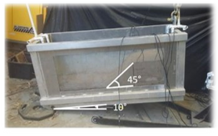
Figure 1: Small Scall Flume

The second image below shows a project on a much larger scale. This experiment is seen to be inside a large testing facility. The levels of elevation and the mixture of materials is something to be taken account of in this size of a testing apparatus,
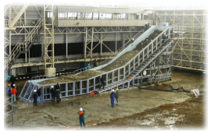
Figure 2: Large Scall Flume

Teamwork
The strategies implemented for this project relied heavily on proper communication and teamwork. Throughout the project, our team would evaluate the weekly status of the project, brainstorm what the next tasks were, and work together to complete these tasks accordingly to move further along in the project. Every Sunday evening, both project members would either meet in person or video chat to discuss the weekly plans. Also, every Wednesday morning the team would meet with the project advisor. This meeting would consist of a discussion of the project status and specific goals to be achieved by the following weekly meeting. Other members who aided the team were Mr. Justin Amos and Dr. Adam Tennant. Throughout the entirety of the project, the team and project advisor relied heavily upon email, One-Drive, and Microsoft teams to communicate properly and effectively.

Discussion

Design 1
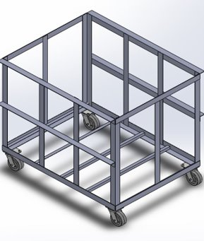
Figure 3: Initial Design
Pictured above in Figure 3 the 3D model of the initial design. It is a 4ft long by 3ft wide by 3ft tall flume with 4 casters that were rated at 300lb per caster. The walls of the flume are a clear, ½ inch thick polycarbonate material that would allow visualization of the experiments. Throughout the design phase of this project, SOLIDWORKS was utilized. Not only did the 3D model provided a great visualization of the flume, but it also provided finished drawings of the flume with dimensions that was extremely beneficial in the construction phase. This structure design involved the specific materials such as angle iron and iron flats. All of the metal involved was 1/8th inch thick. As seen above, there are 4ft angle iron beams that span longways across the structure. This was implemented to increase rigidity of the structure and also on the top, it provided a flat surface that a tabletop could mount to. After group discussion, it was determined that this initial design was too big and would exceed the weight of the casters selected.

Design 2
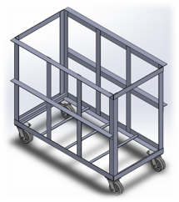
Figure 4: Final Design
Pictured above in Figure 4 is the 3D model of the final design. It is a 4ft long by 2ft wide by 3ft tall flume with 4 casters that were rated at 400lb per caster. This design also includes the use of the clear polycarbonate material for the walls. The width of the flume was reduced from 3ft to 2ft which reduced the total weight of the flume. Even with this modification, the flume still exceeded the weight ratings of the initially selected casters so a caster with a heavier rating of 400lb was selected. Just like the initial design, this design also involved the same materials such as angle iron/iron flats and all of the metal involved was still 1/8th inch thick.

Design Process

SOLIDWORKS
During the design phase of this project, the team began with brainstorming and sketching flume model ideas on paper and then discussed the sketched ideas with the project advisor. After the first design was decided, SOLIDWORKS software was used to build a 3D model. This model supplied a good visual representation of the flume structure at all views and angles. It also supplied a method of analyzing material properties of the structure and gave the team the ability to have exact dimensions of the flume that could be used in the construction phase of the project. As the design phase went ahead, the team and Dr. Ellert made multiple changes to the design of the structure and these changes were implemented in the SOLIDWORKS model as well. After figuring out what the final design of the flume structure was, the model was put into several official SOLIDWORKS drawings that had basic dimensions, a Bill of Materials, and any key notes associated with the project.

Construction
In the construction phase of this project, our team had to participate in essential training and learn a new skill to complete the flume. With the help of the Applied Engineering Center Lab Manager, our team was able to complete the training and learn how to weld. Our team then moved right into welding the pieces one by one while making sure every piece was the right size and in the correct orientation.
MIG welding specifically was chosen to properly attach the steel pieces together. This type of welding included specific settings and setup to adapt to the material we were welding together. A setting of 10-gauge material and the use of .35 mm wire gave the team appropriate values to set the MIG welding machine dials to. The team used clamps and squaring tools to get the steel pieces properly placed prior to the welding step. This ensures stabilization and accuracy when attacking this step.
First, our team started constructing the walls of the flume. This was most beneficial in starting the flume off in the right direction. We knew that if our team got the walls were completed first, this would aid in attaching all of them together. These walls consisted of the flat steel and angled pieces as well. It was essential these walls were very sturdy considering they would bear most of the weight and pressure being applied to the flume.
Second, we used the walls constructed to start creating a square frame. Our team measured similar distances from each wall to ensure that the frame was square. From our team began to weld them together using the distance of 2 feet between them.
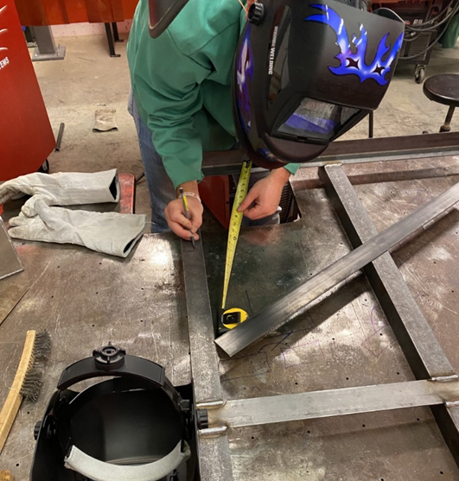
Figure 5: Flume Wall Construction
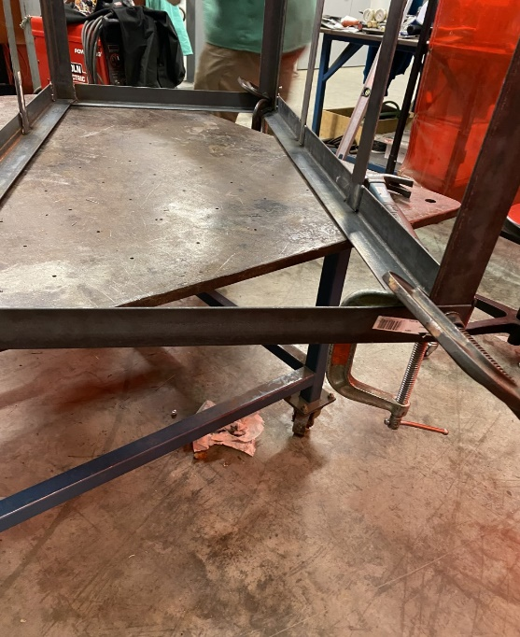
Figure 6: Clamps and Fixtures
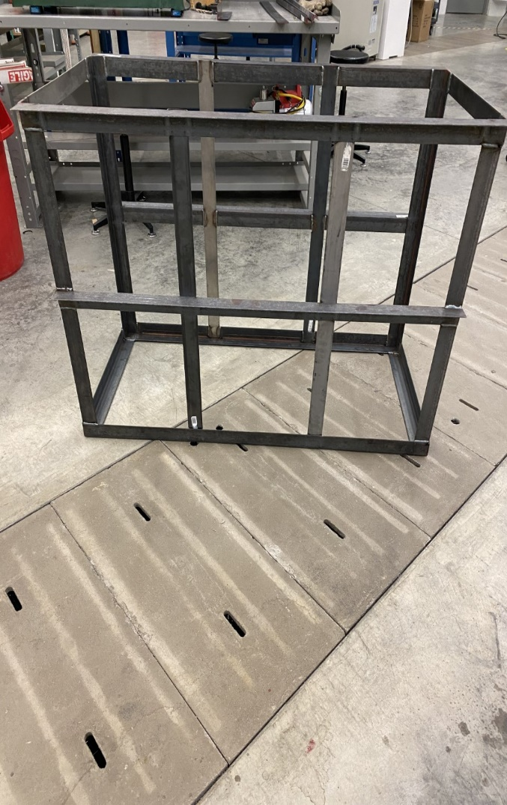
Figure 7: Finished Flume Structure
We welded every seam along the frame. This makes the framework of the flume ultimately stronger and less likely to flex. Pictured above is the finished frame showing the construction of each piece and the physical work we performed on each piece. This portion of the construction phase took approximately 10 hours.

Future Use
This flume’s intended use is for future slope stability testing and demonstrations by the Civil Engineering Department. This team hopes that its efforts to professionally design and construct this flume will pay off and that the flume can last for many demonstrations. This flume was designed and constructed to potentially also be used for other convenient purposes as well such as a storage bin for materials and a mobile tabletop for classroom use.

Bill of Materials

Choice of Materials
The choice of our materials had to be strategically planned out due to the weight the flume was going to be withheld. Each aspect of the flume was researched and carefully discussed among the team and both Dr. Ellert and Dr. Tennant. With the help of specification data and the opinions of the teams aiding professors, the concluded choices of materials were steel for the frame structure and polycarbonate for the walls. Everyone felt like this would be the most effective way to safely withhold the weight attribute while also being able to effectively display the results to spectators.

Cost Analysis
A budget was given to the team by the USI Engineering Department. This budget included a $500 spending allowance and access to any available tools and scrap materials found in the Applied Engineering Center. The team spent a proper amount of money on materials and stayed within the agreed budget. The materials chose, both steel and polycarbonate, were readily available via Lowes Home Improvement Store and the scrap materials found in the AEC (Applied Engineering Center).

Conclusion

Personal Findings
During the construction phase of our project, it was essential that the frame was welded permanently. This forced our group to engage in proper welding training and actually perform welding tasks. Learning and experiencing the welding aspect of this project was not only fun but also is a rare skill that can be used in the future. Our team did not have very many other obstacles other than the drain concept. There are all kinds of solutions to this problem we faced.
As a team, we considered a few types of solutions. First being some sort of door concept on a polycarbonate wall of the flume. This would be most efficient when trying to empty out substantial amounts of material at one time, but this concept would have to be able to withstand the pressure of the material on the door and would have to be watertight. The second concept would be the implementation of a PVC drainage cap. This concept could be possible on all sides of the flume. Whether that is sealed properly to the bottom of the flume or properly places on side facing to be tipped over. This concept would have minimal cutting on the flume, so the integrity of the flume is not compromised.

Results
In the end stage of this project, our group was able to effectively create a steel frame to be used for future demonstrations. This included the use of all angle iron and flat iron pieces being used to construct this structure. This flume was properly squared and welded together.

Appendix
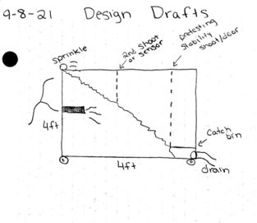
Figure 8: 2D Conceptual Design Sketch
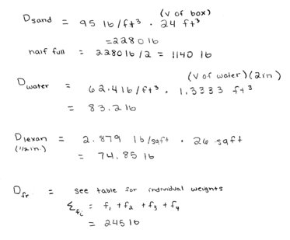
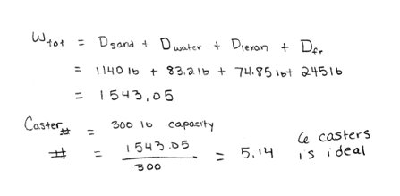
Figure 9: Weight Calculations

